

Router & Switch Ios

**Platform:** https://racks.uninets.com

**Lab Name:** CCNA RS

**Topology**

Router & Switch Ios

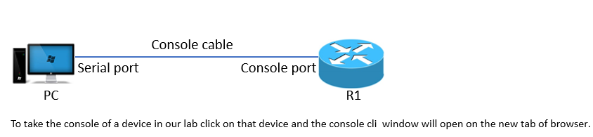

**Task**

* Understanding Cisco ios naming convention and type of ios and there feature.
* Identify what IOS Version and Features Set your Cisco device is currently running.

**Explanation**

The most common way of obtaining IOS identification information is by using the show version command. This command shows various information pertaining to the Cisco IOS Version and Feature Set as well as hardware information about the router. As of 2006, Cisco has introduced a new naming convention for feature sets. This new naming convention started in 12.3 and was implemented as the feature set naming standard in 12.4. The recent IOS versions are 15.x. We are using 15.4 IOS on routers in our labs.

Breaking Down of the Image Name and Extension

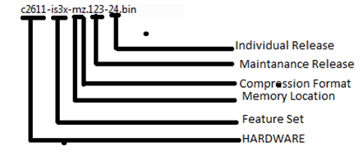

Below is a chart comprised of common pre-standing naming convention identification letters

|  |  |
| --- | --- |
| **Image Letter** | **Feature Set** |
| I | IP |
| Y | IP on 1700 Series Platforms |
| S | IP Plus |
| S6 | IP Plus – No ATM |
| S7 | IP Plus – No Voice |
| J | Enterprise |
| O | IOS Firewall/Intrusion Detection |
| K | Cryptography/IPSEC/SSH |
| K8 | 56Bit DES Encryption (Weak Cryptography) |
| K9 | 3DES/AES Encryption (Strong Cryptography) |
| X | H323 |
| G | Services Selection Gateway (SSG) |
| C | Remote Access Server or Packet Data Serving Node (PDSN) |
| B | Apple Talk |
| N | Novel IP/IPX |
| V | Vox |
| R | IBM |
| U | Unlawful Intercept |
| P | Service Provider |
| Telco | Telecommunications Feature Set |
| Boot | Boot Image (Used on high end routers/switches) |

|  |  |
| --- | --- |
| **Image Letter** | **IOS Boot Location** |
| f | The image executes from Flash memory. |
| m | The image executes from RAM. |
| r | The image executes from ROM |
| l | The image is re locatable. |
| z | The image is compressed using ZIP format. |
| x | The image is compressed using MZIP format. |
| w | The image is compressed using STAC format. |

Below is a feature tree comprised of the new naming convention used for Cisco router images 12.3T and above.

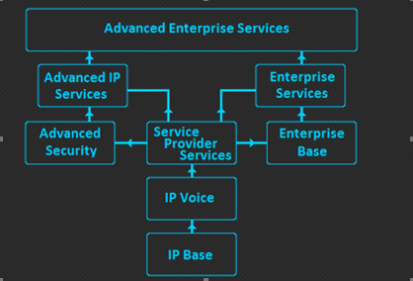

You can see that IP Base is the basic image, from this image it branches off into IP Voice, Advanced Security or Enterprise Base. IP Voice also has an upgrade to Service Provider Services, which includes SP Services Features, IP Voice Features and IP Base features. Only “Advanced” Images contain Advanced Encryption Standard (AES) Cryptography The following categories summarize the new naming convention:

|  |  |
| --- | --- |
| **Feature Set** | **Description** |
| Base | Entry level image (IP Base, Enterprise Base) |
| Services | addition of IP Telephony Service, MPLS, Voice over IP, Voice over Frame Relay and ATM (Included in SP Services, Enterprise Services) |
| Advanced | Addition of VPN, Cisco IOS Firewall, 3DES encryption, SSH, Cisco IOS IPSec and Intrusion Detection Systems (IDS) (Advanced Security, Advanced IP Services) |
| Enterprise | Addition of multi-protocols, including IBM, IPX, AppleTalk (Enterprise Base, Enterprise Services) |

Just like the new naming convention for Cisco Router IOS, Cisco has given the Switch IOS a new naming convention as well. This naming convention is very similar to the router IOS naming convention. Shown below is a feature tree of the new switch IOS naming convention

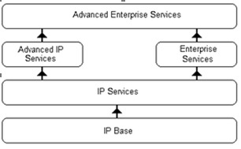

**IP Base:** formally known as Standard Multilayer Image (SMI) on Cisco Catalyst 3550 Series switches includes advanced quality of service, rate limiting, access control lists (ACL’s) and basic static and RIP routing functionality.

**IP Services:** formally known as Enhanced Multilayer Image (EMI) on Cisco Catalyst 3550 Series Switches has a more feature rich set of enterprise-class routing functionality as well as advanced hardware-based IP Uni cast and IP Multicast routing, policy based routing (PBR).

Advanced IP Services is not available as a pre-installed license but is available as an upgrade license. This feature set includes IPv6 routing and IPv6 ACL support.

**Enterprise Services & Advanced Enterprise Services**are the cream of the crop. The images include all features available to the platform; also these license(s) are the most expensive. These license(s) are only supported on various modular switches such as the Catalyst 4500, 4900, 6500 and others

**Configuration**

To check the version of the ios running on cisco router or switch you can run the show version command as shown below with the output

Router#show version

Cisco IOS Software, Linux Software (I86BI_LINUX-ADVENTERPRISEK9-M), Version 15.4(2)T4, DEVELOPMENT TEST SOFTWARE

Technical Support: http://www.cisco.com/techsupport

Copyright (c) 1986-2015 by Cisco Systems, Inc.

Compiled Thu 08-Oct-15 21:21 by prod_rel_team

ROM: Bootstrap program is Linux

Router uptime is 5 minutes

System returned to ROM by reload at 0

System image file is "unix:/opt/uninets/addons/iol/bin/i86bi_linux-adventerprisek9-ms.154-"

Last reload reason: Unknown reason

This product contains cryptographic features and is subject to United

States and local country laws governing import, export, transfer and

use. Delivery of Cisco cryptographic products does not imply

third-party authority to import, export, distribute or use encryption.

Importers, exporters, distributors and users are responsible for

compliance with U.S. and local country laws. By using this product you

agree to comply with applicable laws and regulations. If you are unable

 --More--

The above is the output of show version command on a Cisco router depicting that is it is running 15.4 IOS version with advance enterprise feature set image.